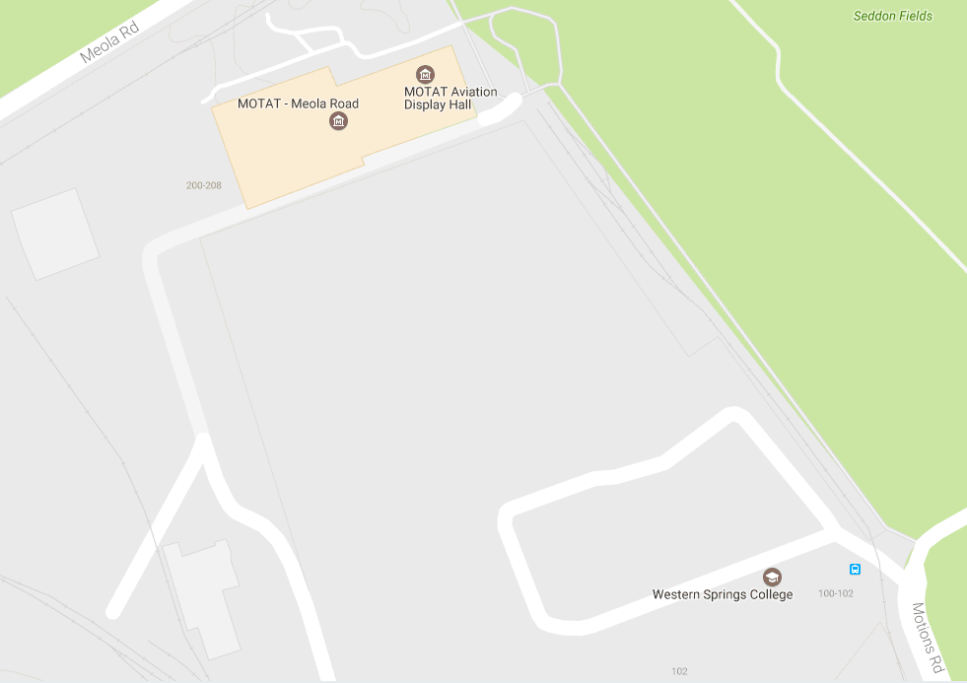
WSC Sports Facilities

PCAAC Field Access (GATE)
Discus
Shotput
Long Jump
Container

Sprint Track
High Jump

Admin/BBQ
OUT OF BOUNDS AREA /
DANGER ZONE
NOT PERMITTED ON SCHOOL GROUNDS
Junior Activity Area 3 – 6’s

NO ENTRY

